Topic: Hybrid FRCSENT VIVA COURSE
Time: Sep 6 & 7, 2023 08:30 London
Join Zoom Meeting

You must not share this email to others.

How to Join
1. download zoom app if not installed already
2. Click the following link,

https://us02web.zoom.us/j/85419586353?pwd=Y09ReXRpbUxPallGSWJ6clk1ZVcrdz09

3. when prompt, “do you want to allow this page open zoom.us”, click ‘allow’.
4. It will allow you in the meeting waiting room directly. We will admit you. Check your audio in the meantime. If prompts join with computer/phone audio.
5. Alternative options include via entering Name or email, meeting ID and passcode into zoom app.

6. Joining from mobile/pad is also very easy if app installed in similar way.

Meeting ID: 854 1958 6353
Passcode: 922580

For programme, please see other attachment

Audio setup
Please worth watching this video as well. You may have to change audio settings in case of mic or speaker issues.
https://youtu.be/-s76QHshQnY

Rename function
To change your name after entering a Zoom meeting, click on the “Participants” button at the top of the Zoom window. Next, hover your mouse over your name in the “Participants” list on the right side of the Zoom window. Click on “more” then “Rename”. Enter the name you'd like to appear in the Zoom meeting and click on “OK”.
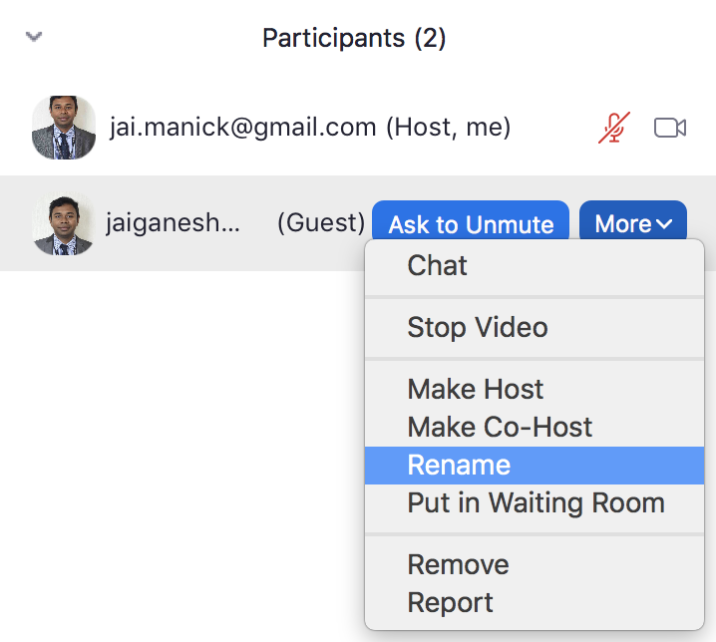

Delegates will be given unique delegate number; you must remember and stick to your timetable. Your name has to be renamed by yourself with rename function. Such as D1 (your name), D2 (your name) for delegates and OB1(your name) -if you are an observer. Faculties are requested to rename such as R1 Faculty Pete Ross, R2 Faculty Siew…

Breakout rooms
We have divided 6 breakout rooms (A,B,C,D,E and F) for clinical stations(Day 1) and 9 (O1,O2,R1,R2,P1,P2,H1,H2& (C1,C2) (day 2)breakout rooms for viva stations. For best experience please download/update ZOOM 5.3 or later versions (instructions given at page 4), you can join by yourself to different breakout rooms. We can move your place as well if you have problem. After that please press ‘join’ button to go into the breakout room.

Breakout room Instructions

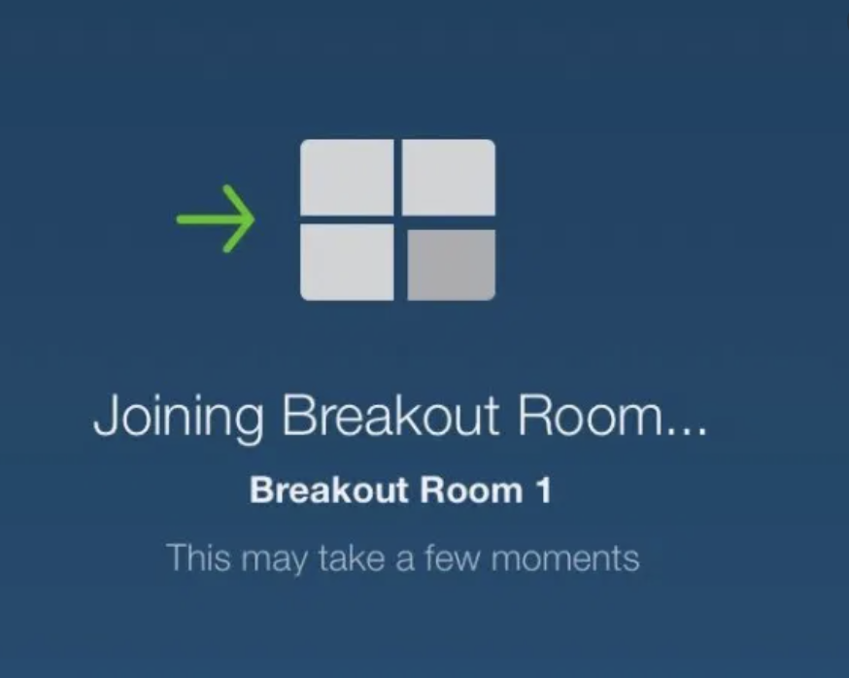
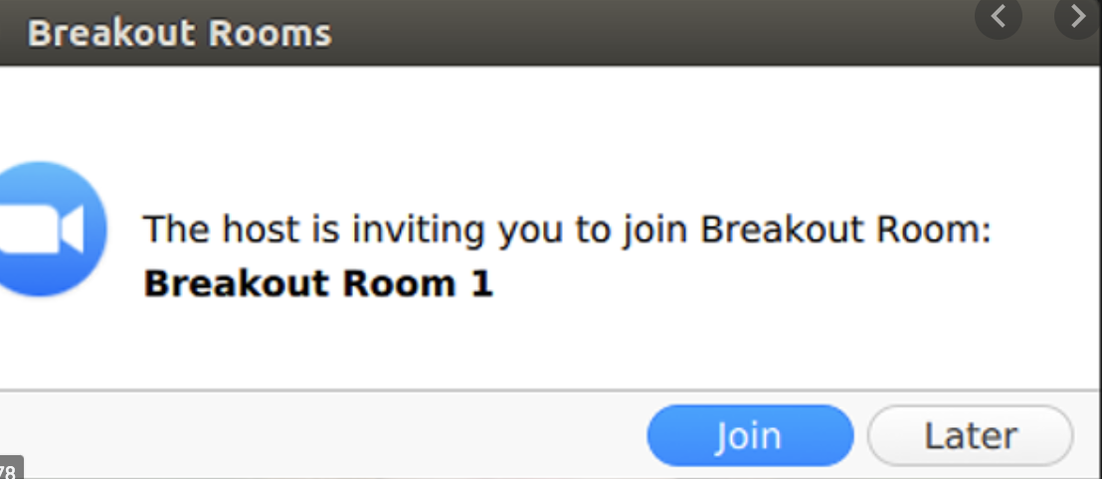

Once you press the Join button, you will be moved to breakout room

From the breakout room you can “leave the meeting” or “leave the breakout room” or switch to other room. 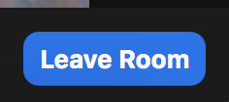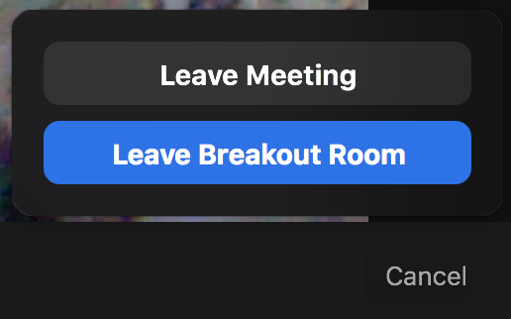
If you leave the breakout room, you will come to the main meeting room. You can also hop between different rooms. 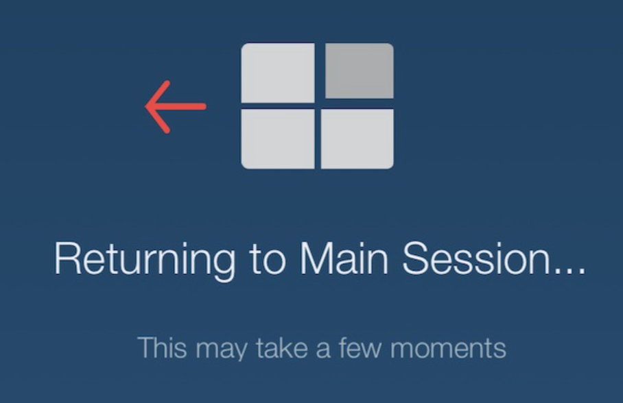 To choose another room, press (4 squares) “Breakout rooms” sign.
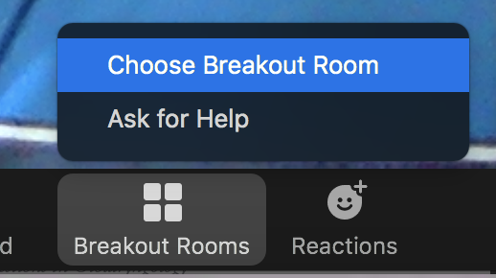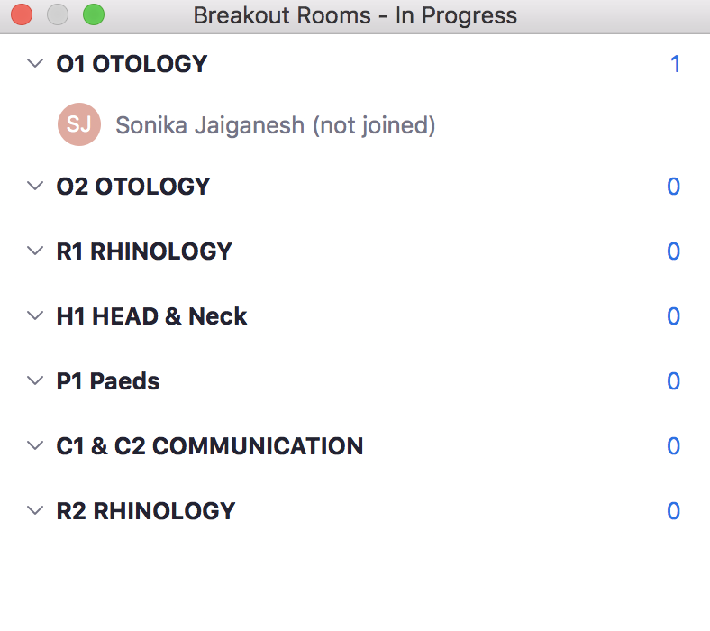
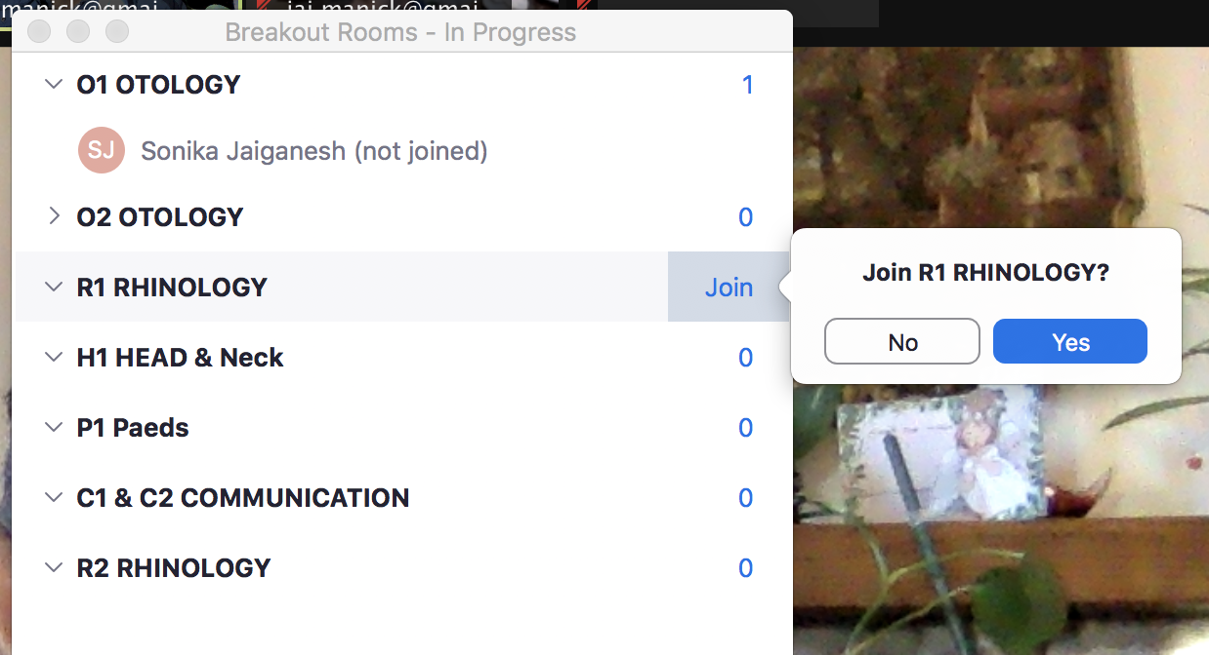

NOTE- In some computers such as MAC, mouse need to be swiped all the way to right end to get “join” sign

5.3 version ZOOM update – please go to https://www.zoom.us
Find “Resources”- “Download zoom client”- Download zoom client for meeting- complete process
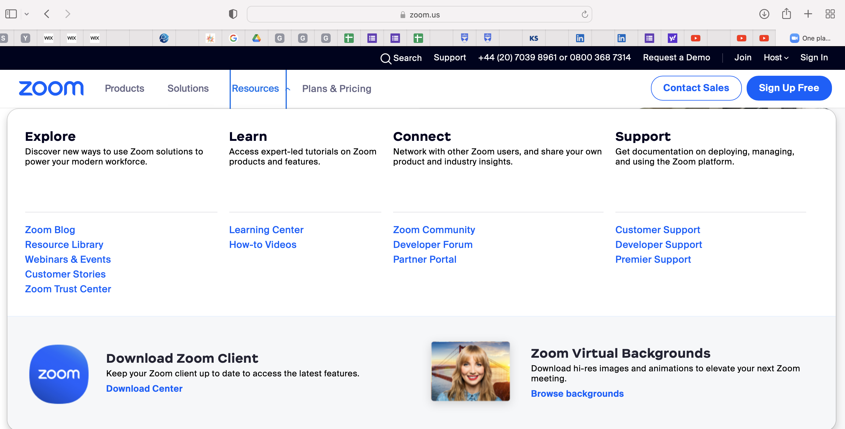

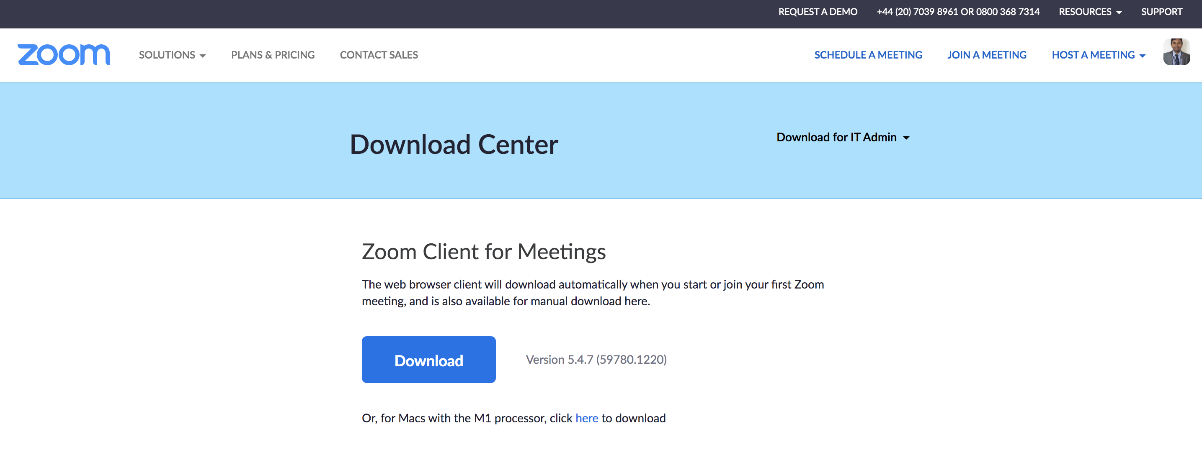
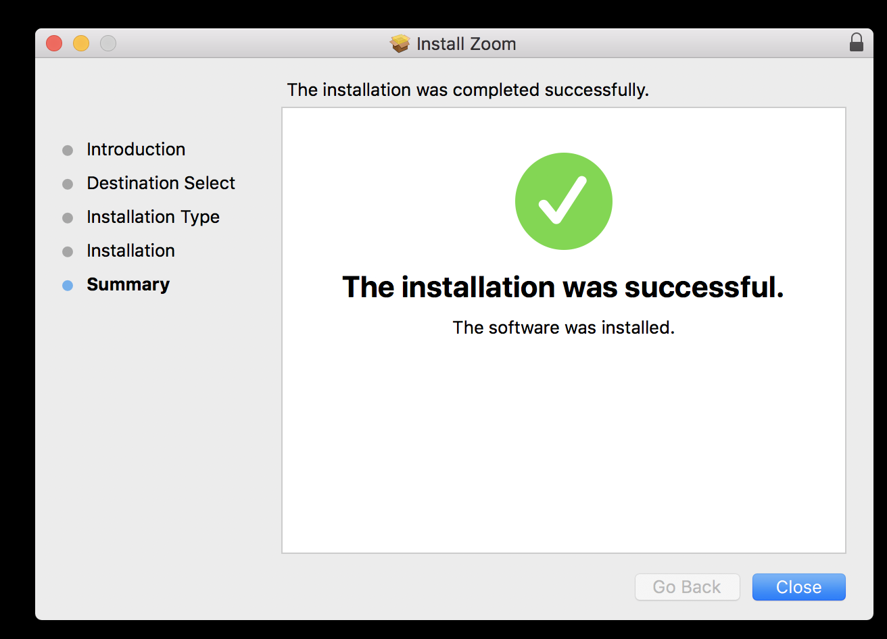

Screen share
Press “share screen”, choose desktop/screen or selected opened files then press “share”
Click “share computer sound” if it is audio files

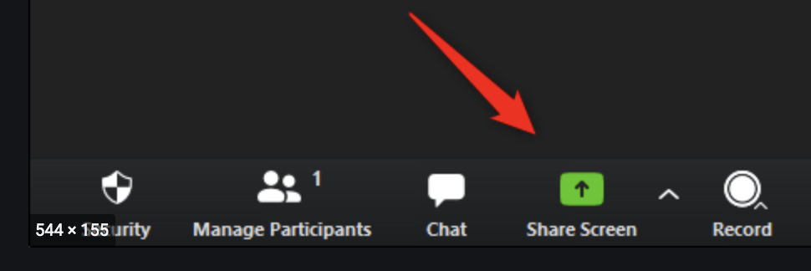
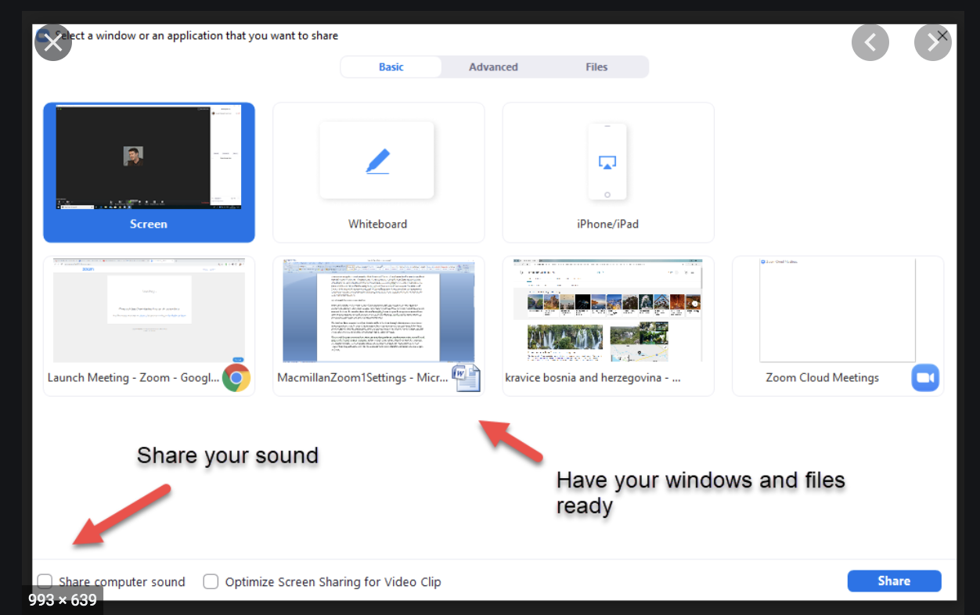
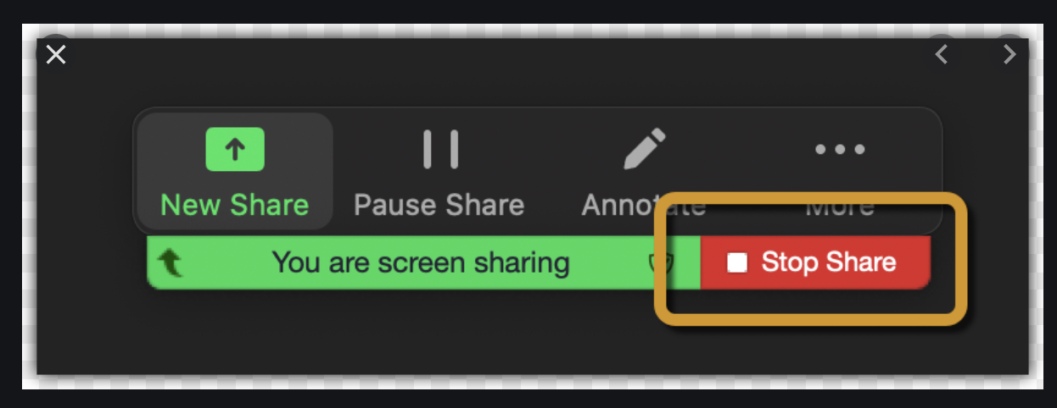

Trial Run
Is planned on during precourse top tip talks on the 2-3 evenings. The meeting will be open with the above link. You must make sure it works well. Please make sure you got good internet without interruption like microwave, more usage at home, etc…
During viva you will have 30 full mins for practice and 8 mins for feedback and 2 mins for breakout room change. Communication station is planned for 20 mins. 2 delegates will be attending this station one after another.
If any error, please chat with me or call/text me 07983364439 or linda 07902903406.

It is a complex task to rotate nearly 50 people. We are trying our best. Past 4 courses went very well. Advanced apologies if it is a disaster.

