2/10/2020
www.frcsentvivacourse.co.uk |
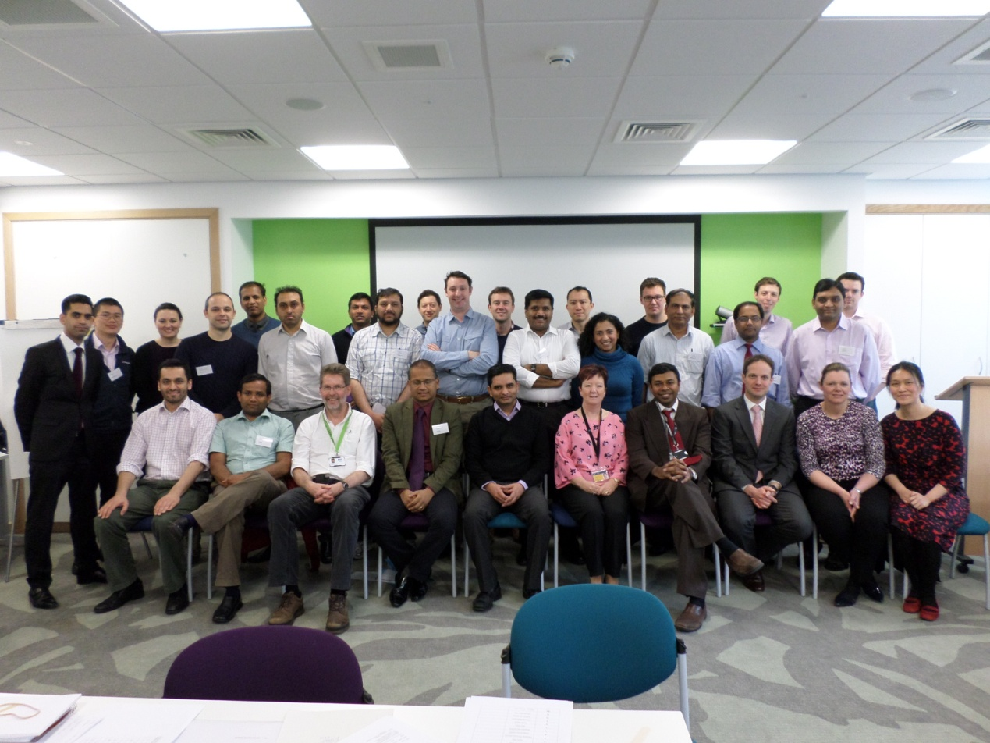
Dundee FRCS viva course brief for Faculty

FRCS viva course brief for Faculty

FRCS (ORL) Section 2 (JCST)

Section 2 is the clinical component of the examination. It will consist of a series of carefully designed and structured interviews on clinical topics – some being scenario based and some being patient based.

1. Oral Examination (4 x 30 minute orals) as follows:
• Otology including Neuro‐Otology
• Head & Neck Surgery
• Paediatric Otolaryngology
• Rhinology & Facial Plastics ‐ (Facial Plastics will cover otoplasty, rhinoplasty, flap reconstruction, excision of facial lesions, suturing techniques, tissue handling and assessment of patients undergoing cosmetic procedures)

(Pertinent to which, candidates should have a knowledge of Basic Sciences, Clinical presentation and progression of disease processes, Investigative procedures, Management policy of disease processes, Operative techniques, including reconstruction)

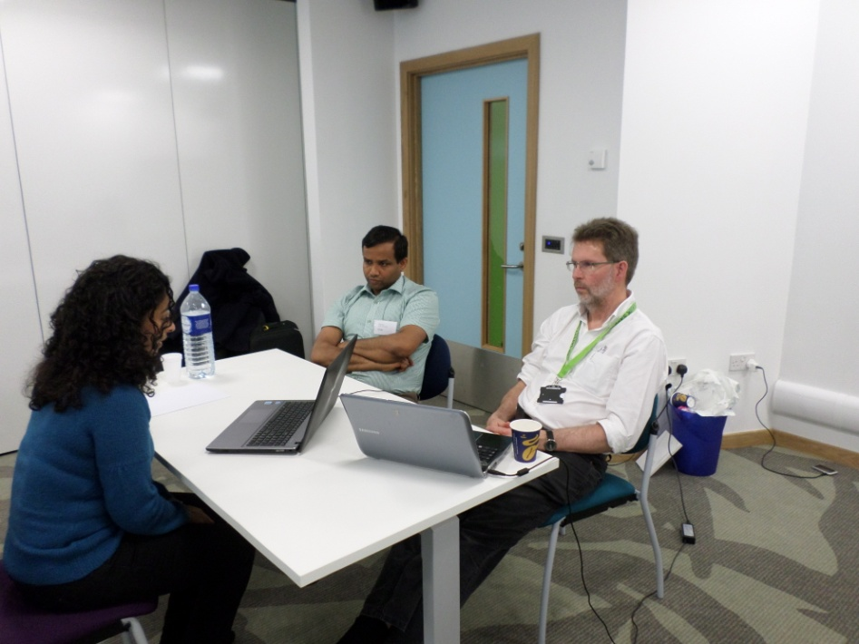

2. Clinical Examination as follows:
• History Taking & Communication Skills (20 minutes)
• Clinical short cases on the following domains: (two 20 minute sessions)

Otology including Neuro‐Otology, Paediatric Otolaryngology, Head & Neck Surgery and
Rhinology & Facial Plastics

For further indication of the Examination Scope, candidates should consult the Curriculum as published by the SAC in Otolaryngology [www.iscp.ac.uk].

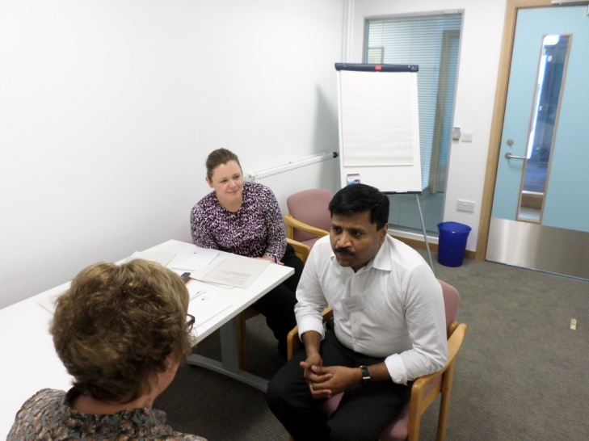
Viva Course layout:

There are 3 sections to the course:
- Oral examination (viva)
- Clinical examination
- Communication skill

Viva section

For the viva section on day 1, each candidate should be questioned on at least 5 topics (5min each topic = 25 min) and 5 min feedback. There will be time keeper at the course ringing bell at 25 min and 30 min to indicate that the delegate will have to move to the next station after feedback. The viva section for day 2 will only be 20 min in total for each delegate. Although we do try to arrange for 2 faculty members per table but sometimes there may only be 1 faculty per table. If there are 2 faculty members per table, please do swap round half way (15 min for 30 min viva) or do swap for alternate stations. For day 2, the delegates will only get 4 topics and the last topic will have a shorter questioning time if the faculty will like to give the delegates feedback at that station.

The course runs on a tight schedule and we advised all faculty members to try to keep to time.

The organisers are aware that most of the faculty members have a wealth of knowledge and experience; especially coaching trainees for the FRCS exam. However, for those who are less certain, an example of the style of questioning will be as follows:
- An opening question to put the candidate at ease either with a picture, audiogram, instrument etc. This may carry no points.
- This should be followed by questions of increasing difficulty.
- Each topic should have 3 levels of questions.

Clinical skill section (15 min each station, including feedback)

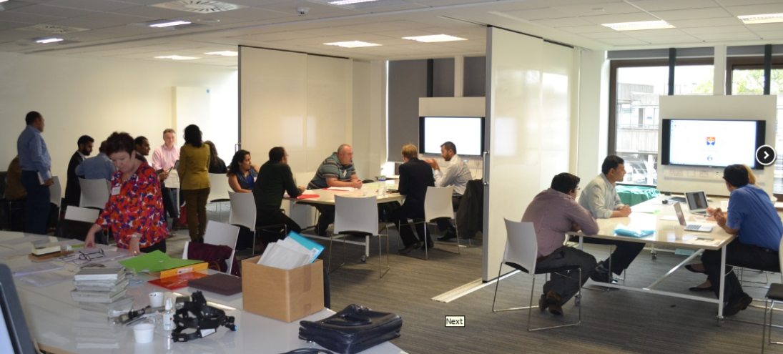
Each delegate will have 3/4 stations with different ENT pathologies. The patients will be stationed at different rooms and the candidates will be directed to the different rooms accordingly. The faculty will stay with the patient and will be told the patient’s history and diagnosis. The faculty will have an opportunity to examine the patient and decide on questions to ask the candidate. There will be a case information sheet for each patient with some photographs, scans, audiograms which can be used for discussions as well.

Feedback should be given to candidate on their performance before the end of the station.

Communication skill section (20 min, including feedback)

Each candidate will have a communication skill station. The actors will be notified and brief on the scenarios before the course and on the day.

Feedback should be given to candidate on their performance before the end of the station. Please also provide advice on how to approach a difficult situation if the candidate appears to struggle with the station.

Scoring sheet/Feedback for delegates
In the FRCS (ORL) exam, the marks for the viva section for each topic is marked from 4 (poor fail), 5 (fail), 6 (borderline pass), 7 (clear pass), to 8 (excellent).

It will be good if the faculty could give a constructive feedback in the last 5 minutes of each station as this will help the delegate to address any areas where they have done well and areas for development.

Faculty Travel Expenses claim/Hotel stay

Please liaise with Linda for claim form and for hotel stay

